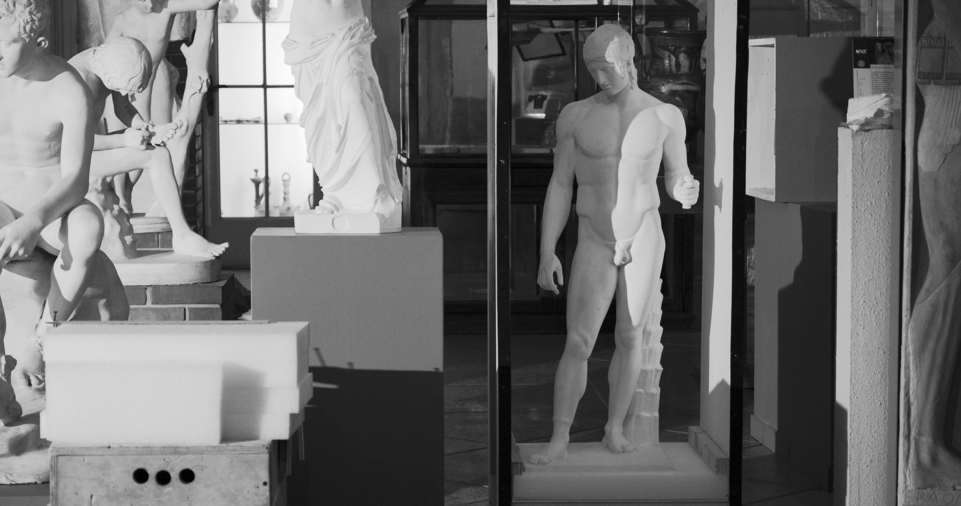

**LE CIME DI ASCLEPIO**

(THE ROPES OF ASCLEPIUS)

**documentary**

**running time:** 17’32’’

**completion date:** April 2024

**country:** Italy

**shooting format**: 4k

**screening format:** 2K DCI: DCP, file, Blu Ray

**language:** no dialogue

**subtitles:** English

**FESTIVAL**

42° Bellaria Film Festival – Concorso Gabbiano (Italy)

**SINOPSYS**

A museum is emptying out. What normally inhabits it changes position and perspective. Can objects, statues, relics die?

**DIRECTOR’S NOTE**

The film recounts the emptying of an archaeological museum by trying to take on the point of view of the inanimate protagonists. I wanted to tell the story of the loss of the aura of these ancient and immortal objects, which are confronted with what is corruptible: the human being.

**DIRECTOR'S BIO-FILMOGRAPHY**

Filippo Ticozzi makes documentaries. His films have participated in many festivals (among others, Visions du Réel, Ji.hlava IDFF, Festival dei Popoli, Full Frame IDFF, Doker Fest, Filmmaker Fest, Bergamo Film Meeting, Laceno d'Oro, etc.) and have won several awards (*Special Jury Prize* at Torino Film Festival, *Best Documentary* at Cinéma Verité Iran, etc.). He teaches Documentary and Experimental Cinema at the University of Pavia and is the one in charge of Officine Creative.

**COMPANY PROFILE**

Officine Creative is a Research Facility part of the Department of Humanistic Studies at the University of Pavia. Founded recently (2020), it deals with research in the field of visual and performing arts, teaching methodology and audiovisual and theatrical production.

**CONTACTS**

filippo.ticozzi@unipv.it, officine.creative@unipv.it

ph. +393485181553