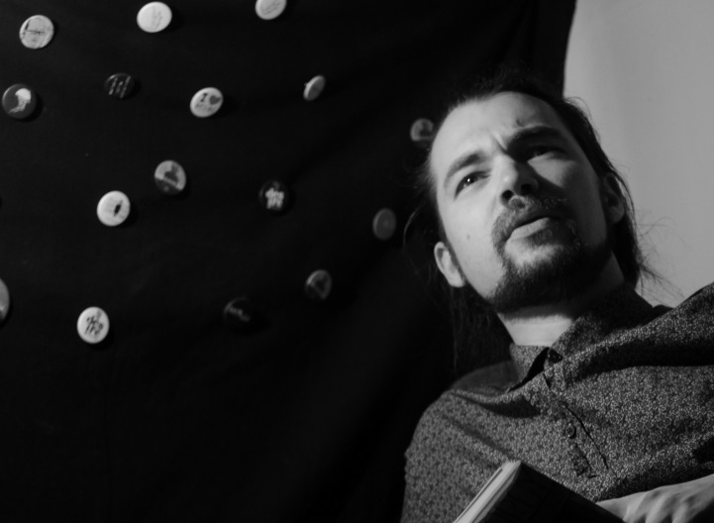

**ATTILA ANTAL**

Theatre and film director.

Composer. Performer. Author

Theatrologist.

[doktoraat@gmail.com](mailto:doktoraat@gmail.com)

+36 30 721 0177

<https://vimeo.com/attilaantal>

*EDUCATION*

2015 - present DLA Theatre Theories and Theatre History. Candidate DLA

*University of Theatre and Film Arts, Budapest, Hungary*

2010 MA Theories of dramatic arts and the media.

*Faculty of Dramatic Arts, Belgrade, Serbia*

2008 MA Theatre and lilm direction.

*Academy of Arts, Novi Sad, Serbia*

*EMPLOYMENT*

2019 – ***lecturer*** *at the University of Theatre and Film Arts, Budapest*

2010 – present: ***freelance theatre and film director****,* member of the *Society of Drama Artists of Serbia* and *ASSITEJ Serbia*

2012-2013 ***project manager***IPA Hungarian-Serbian joint project ThePer (Pass-port Trilogy); MASZK Szeged, Hungary/Kosztolányi Dezső Theatre, Subotica, Serbia

2012 ***artistic secretary***at the Kosztolányi Dezső theatre, Subotica, Serbia.

2009-2010 ***PR manager***at the Kosztolányi Dezső Theatre, Subotica, Serbia

2008-2010 ***Lecturer*** *at Film and Photography Workshops,* Mediawave, Hungary

*WORKSHOPS, COURSES, RESIDENCIES, CONFERENCES*

2019 Viewpoints in Action – university course for theatre students, SzFE, Budapest

Devised Theatre – university course for theatre student, SzFE, Budapest

The Quest – interdisciplinary workshop leader, Prague Quadrennial, Czechia

Kontaktzónák – theatre conference, Pécs, Hungary

Encounter Regenerates – theatre workshop leader; Brno, Czechia

2018 Theatre Symposium, Janacek Academy of Arts, Brno, Czechia

IFTR Annual Conference, Belgrade

Next Generation Program; ASSITEJ Pakistan, Lahore, Pakistan

Theatre Between Politics and Policies, International Theatre Conference, Belgrade

Theatre and Politics, Theatre Conference, Pécs, Hungary

2017 Writing About Contemporary Artists, International Conference, University of Surrey, Guildford, England

Multimedia and Puppetry, International Puppet Theatre Conference, UNIMA, Bratislava, Slovakia

Desire Central Station International Theatre Festival: Lecture on the Ethics of Post-Dramatic Theatre, Subotica, Serbia

Training Academy – Western Balkans Creative Clash: Artist in Organisations with Tillt, Göteborg, Sweden; Struga, Macedonia

2015 Tanzlabor 21 – dance and theatre workshop, Mousonturm, Frankfurt am Main

Schmetterlingsperformance, butoh workshop with Shusaku Takeuchi, Sommerwerft, Frankfurt am Main

2014 Chairs and Thunders – dance/theatre workshop with Dénes Döbrei, Heni Varga, Subotica Serbia and Collectif Belle Perdue, Toulouse, France

2011 International Film Workshop with Béla Tarr, Split, Croatia

Performance Residency at MDT and Dansens Huus, Stockholm, Sweden

2010 ENPARTS Campus, international theatre, dance and performance residency/workshop, Bitef Theatre, Belgrade, Serbia

Scott Fielding – Actors Studio workshops, Belgrade

Method Acting Workshops, Belgrade

2008-2009 Sterijino Pozorje – New Drama Workshops, Novi Sad

2007 PreGlej na glas! – dramaturgy workshop and new drama festival with various dramatists from Serbia, Slovenia, Croatia, Bosnia, Kosovo; Ljubljana, Slovenia, 2007-2008

*AWARDS*

2016 *Best Music* Festival of Professional Puppet Theatres of Serbia

Performance: *Song of the White Whale*

*Best Music* May Games Festival, Stari Bečej, Serbia

Performance: *Invisible monuments*

2015 *Best Director*Drama Writer’s Competition, Hungary

Performance: *Garden Sale*

2014 *Best Director* Drama Writer’s Competition, Serbia

Performance: *Twenty-Three-Year Dream*

*Best Music* Trema Art Festival, Serbia

Performance: *Monologue*

*Best Total Design*Trema Art Festival, Serbia

Performance: *Monologue*

*Best Music* Festival of Theatres of Voivodina, Serbia

Performance: *Neoplanta*

2010*Best Puppet Performance*Milena Načić-Award, Serbia

Performance: *Swallow and the Tomcat*

*Silver Plaquette* Unica Independent Film Festival, Switzerland

Film: *Till Dawn Fades*

2009 *Jury’s Special Award*Festival of Independent Film, Hungary

Film: *Till Dawn Fades*

*PRINT MEDIA*

2019 *Szereplők helyett hang* [Sound instead of Actors]; *author;* theatrical essay in *Kontaktzónák*, Pécs, Hungary

2018 *Személyes trauma a színpadon* [Personal Trauma on Stage]; *author;* theatrical essay in *Színházi politika/Politikai színház,* Pécs, Hungary

2011  *Političko u postdramskom pozorištu: Recentni opus Andraša Urbana*

[Political in the Post-Drama Theatre: Recent opus of András Urbán]

*author;* theatrical essay; book; Fokus, Subotica, Serbia

2010-2018 Theatrical essays and critical writings on theatrical prerformances in*Teatron* (Belgrade) and *Scena* (Novi Sad), *Magyar Szó* (Subotica), BITEF Blog (Belgrade), Színház (Hungary).

SELECTED ARTISTIC WORKS

*THEATRE*

2019 Attila Antal – Bernadett Jobbágy:

Hasamban... [Inside my Belly]

*director, composer, co-author*

Patyolat, Budapest

Attila Antal – Bernadett Jobbágy – Dániel Levente Pál:

Akkor majd a gólya [Leave it to the Stork]

*director, composer, co-author*

National Dance Theatre, Budapest

2018 Zsófia Bérczi: *Angster re-generációk* [Angster Re-Generations]

*performer*

Living Picture Theatre Group, Budapest

Bernadett Jobbágy – Attila Antal: A meg nem született [The Unborn]

*director, co-author, composer*

Trafó House of Contemporary Art, Budapest, Hungary

2017 Tarot Maze [dir.: Zsófia Bérczi]

*performer*

Living Picture Theatre Group, Budapest

I Ching Maze [dir.: Zsófia Bérczi]

*performer, co-author*

Living Picture Theatre Group, Budapest

2016 B. Rončević – A. Antal: Nečiji Anđeo [Someone’s Angel]

*director, co-author, composer, stage designer*

Atelje 212 Theatre, Belgrade, Serbia

N. Cave – R. Á. Tóth – A. Antal: Mary és a tenger [Mary and the Sea]

*director, co-author, composer*

„Napsugár“ Puppet Theatre, Békéscsaba, Hungary

H. Melville – A. Antal – L. Kurjački: Pesma Belog Kita [The White Whale’s Song]

*director, co-author, composer*

National Theatre „Toša Jovanović“, Zrenjanin, Serbia

2015 Eugene Ionesco: Macbett

*composer*

Atelje 212 Theatre, Belgrade, Serbia

Angéla Kolozsi: Lomtalanítás [Garden Sale]

*director*

„Napsugár“ Puppet Theatre, Békéscsaba, Hungary

Jelena & Minja Bogavac: Nevidljivi Spomenici [Invisible Monuments]

*composer*

Bitef Theatre, Belgrade, Serbia / Goethe Institut Zagreb, Croatia

2014 Ákos Németh: Babett hazudik [Babett Lies]

*director, composer*

Novi Sad Theatre, Novi Sad, Serbia

Attila Antal: Együtt [Together]

*director, concept, composer, set and costume design*

Summer Cinema Theatre Group, Subotica, Serbia

Zoltán Sándor: 23 éves álom [Twenty-three-year Dream]

*director*

Novi Sad Theatre, Novi Sad, Serbia

Ranko Marinkovic: Glorija [Gloria]

*composer*

National Theatre, Subotica, Serbia

Ildikó Lovas: Spanyol menyasszony [Spanish bride]

*composer*

Kosztolányi Dezső Theatre, Subotica, Serbia

Alexander Vvedensky: Christmas Eve of the Ivanovs

*composer*

Hungarian State Theatre, Cluj-Napoca, Romania

L. Ervin – A. Antal: A hétfejű tündér [The Seven-Headed Fairy**]**

*director, adaptation, concept, stage and puppet design*

„Csiky Gergely“ Hungarian State Theatre, Timisoara, Romania

László Végel: Neoplanta

*composer*

Újvidéki Színház, Novi Sad, Serbia <https://attilaantal.bandcamp.com/>

2013 Attila Antal: Monolog [Monologue]

*author, director, composer, stage and costume design*

Cultural Centre, Novi Sad

Heni Varga – Attila Antal: Somniare Somnia

*composer, performer*

Kosztoloányi Dezső Theatre, Subotica, Serbia/Kobez, Tulouse – France

2012 Pass-Port Europe

*dramaturge, composer, performer*

Kosztoloányi Dezső Theatre, Subotica/MASZK, Szeged, Hungary

Maga az ördög [The Devil Incarnate]

*dramaturge, composer, performer*

Kosztoloányi Dezső Theatre, Subotica/MASZK, Szeged, Hungary

Démonok városa [The City of Demons**]**

*dramaturge, composer, performer*

Kosztoloányi Dezső Theatre, Subotica/MASZK, Szeged, Hungary

2011 Lesley

*co-author, co-director, performer*

MDT/Dansens Hus, Stockholm, Sweden/Bitef Theatre, Belgrade

Three Shadow Plays in the Woods

*director, composer, performer*

Etno HistEria Festival of Performance and Music, Slovenia

O. Wilde – A. Antal: Na vrtu sebičnega velikana [Garden of the Selfish Giant]

*adaptation, concept, composer, director*

Mini Teater, Ljubljana, Slovenia

2010 J. Amado – V. Nikolic – A. Antal:

Prugasti Mačak i Gospojica Lasta [Swallow and the Tomcat]

*director, adaptation; composer*

Malo Pozorište „Duško Radović“, Belgrade

2009 Rona Žulj: Nevet a nap [The Sun is Laughing]

*director, composer*

Kosztolányi Dezső Theatre, Subotica, Serbia

*FILMS, VIDEOS.*

2020 Valami hiányzik [Something’s Missing]

*director, screenwriter, composer;* short film

2018 Tanyaszínház – Images from a 40-Year-Old Traveling Theatre

*author, director, composer;* documentary series

The Quest *director, cinematographer, editor;* short film

2014 Together*director, composer, cinematographer, editor*;

video for the performance

Summer Cinema Theatre Group, Subotica, Serbia

2013 Monologue *director;* video for the performance

Cultural Centre of Novi Sad, Serbia

The Story of Jacques, the Sack-Man, pt II

*director, screenwriter, composer;* music video

Studio 11, Subotica, Serbia, 2013

<https://www.youtube.com/watch?v=pAvu5gutF64>

2011 Fear of Fish*screenwriter, director*; short film

Béla Tarr International Film Workshop, Split, Croatia

<https://www.youtube.com/watch?v=ZJmx3yW65l8>

2010 The Story of Jacques, the Sack Man, pt I

*director, screnwriter, composer*; music video

Mediawave, Győr, Hungary <https://vimeo.com/79237115>

The Journey*director, cinematographer, editor*; 8mm short film

Duško Radović Theatre, Belgrade, Serbia

2009 Till Dawn Fades *director, screenwriter*; short 16mm film

Mediawave Fundation/Hungarian Film Fund, Győr, Hungary

2008 Play! *director, screenwriter, composer*; short 16mm film

Promena Film, Novi Sad, Serbia

LANGUAGES

Fluent in *English*, *Hungarian* and *Serbian*.

Basic communication and writing skills in *German*, *French* and *Slovenian*.

Performances (Selection)

Someone’s Angel (2016)

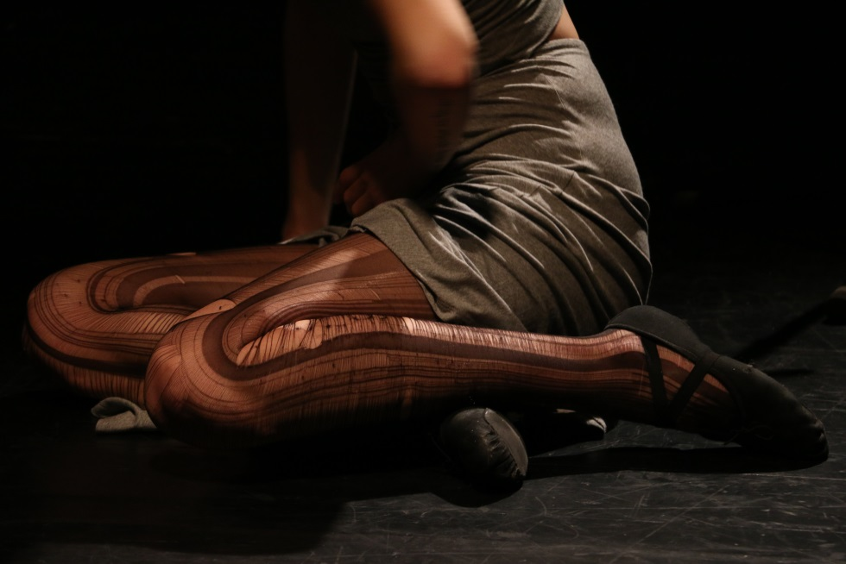

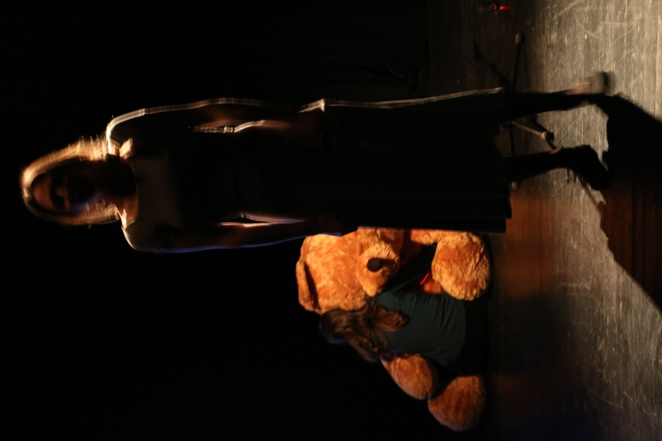 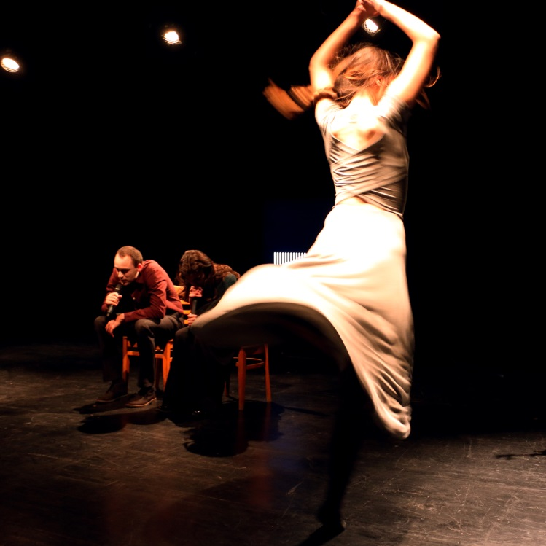

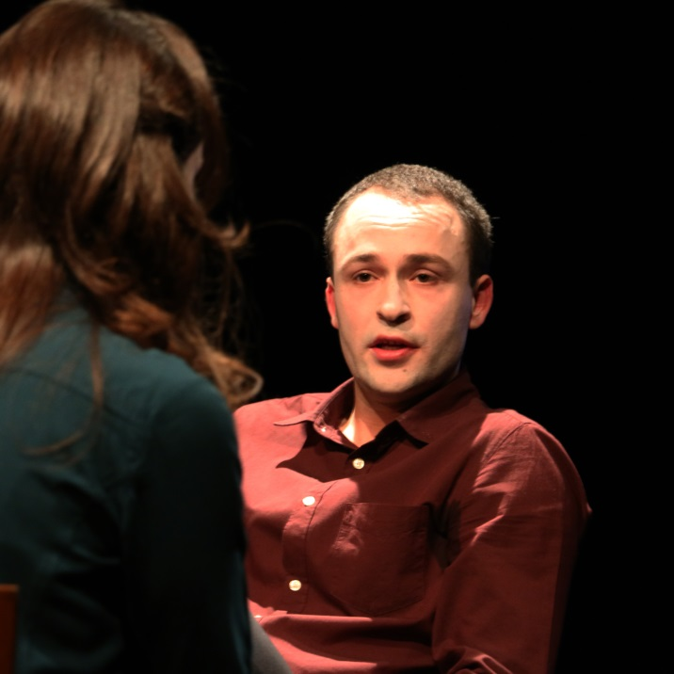

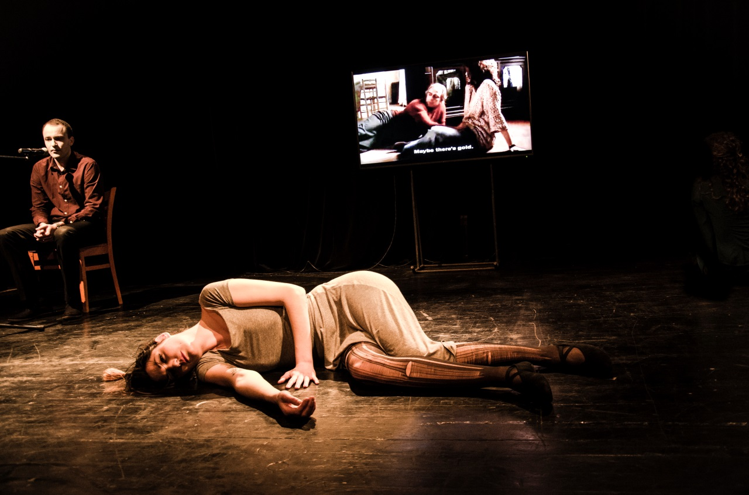

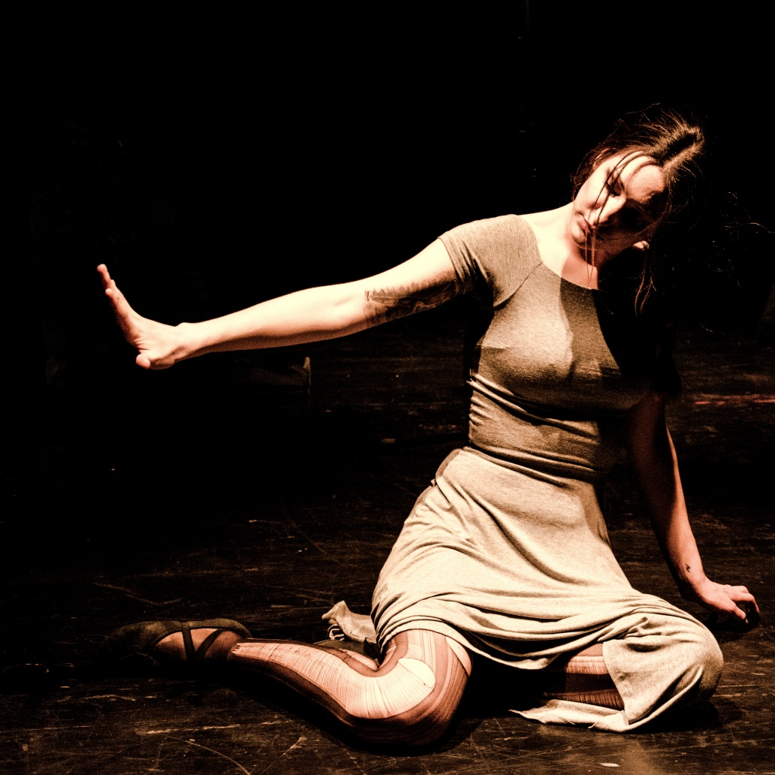

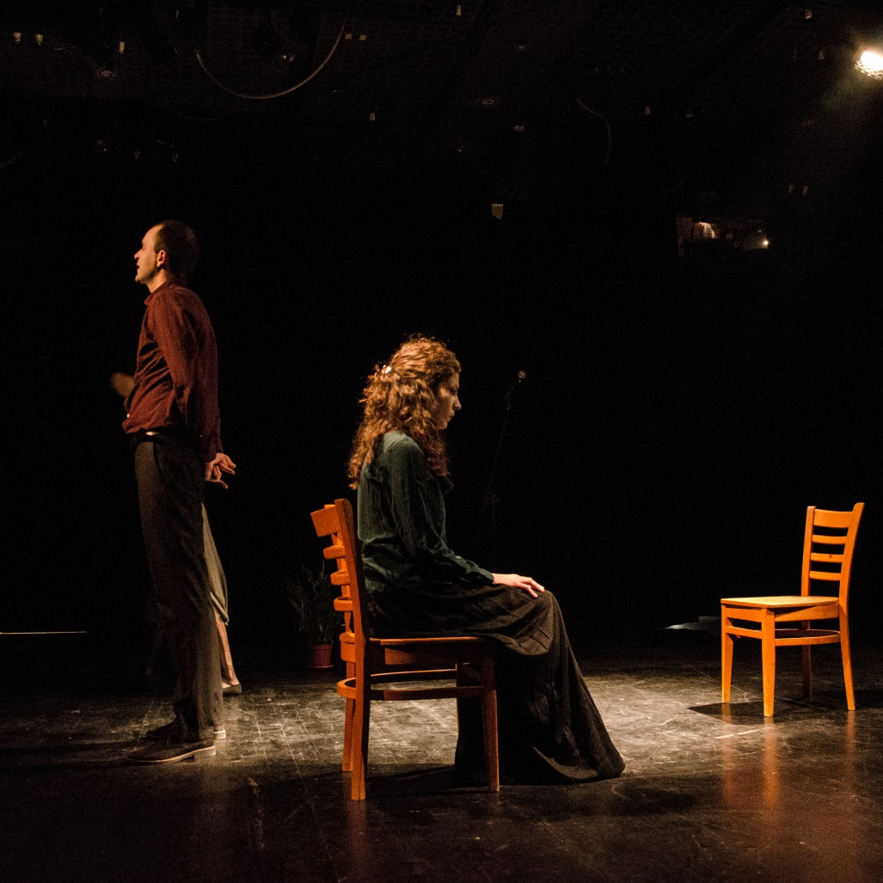

Mary and the Sea (2016)

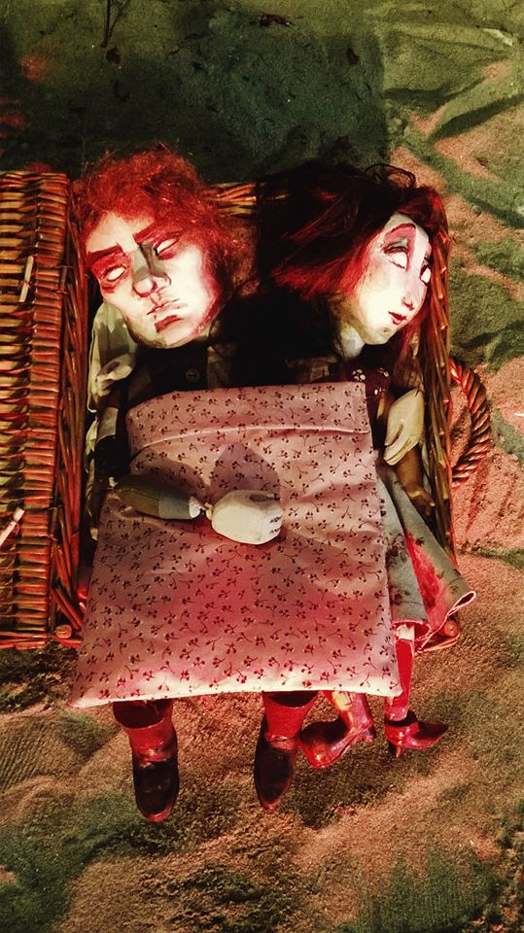

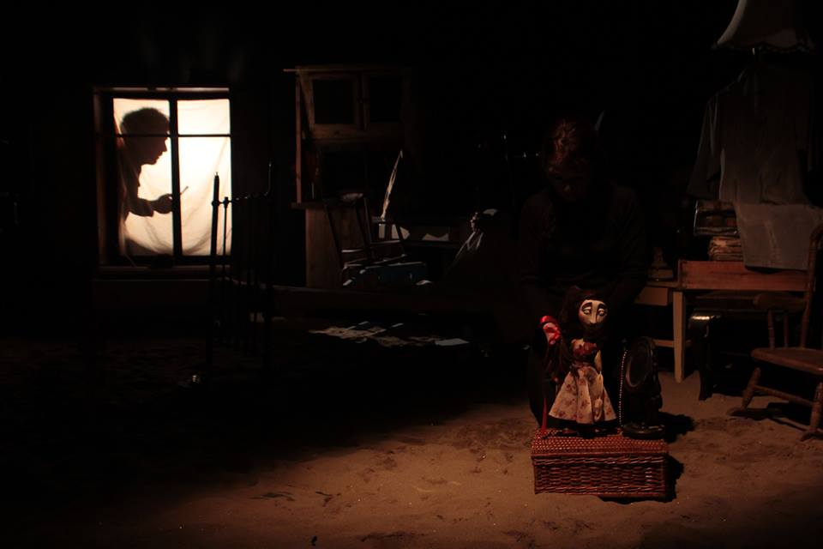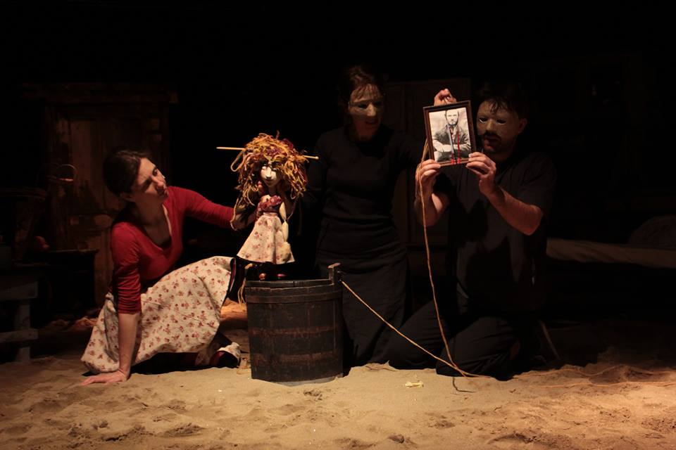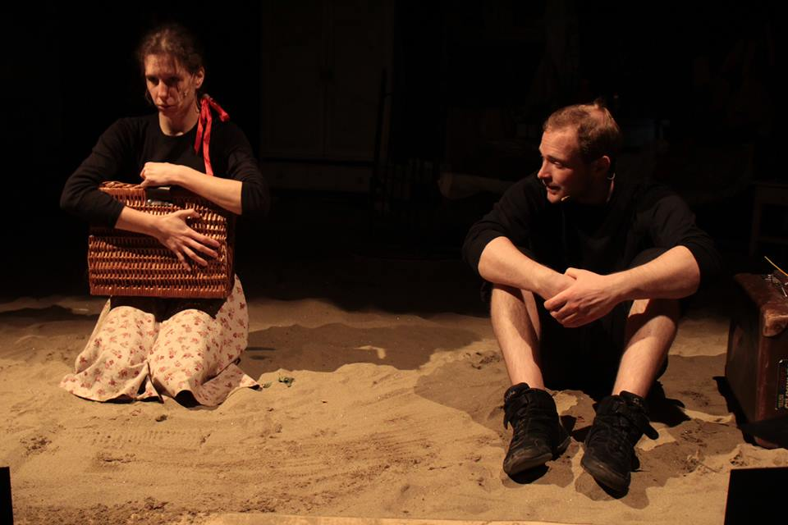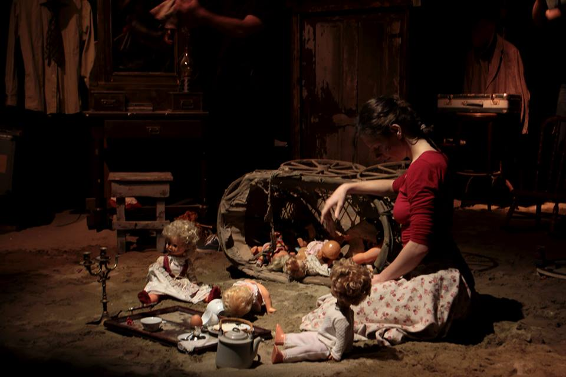

Song of the White Whale (2016)

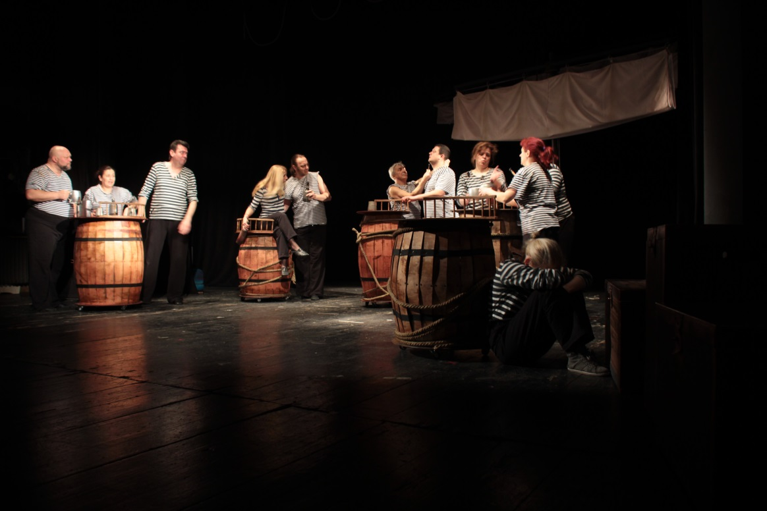

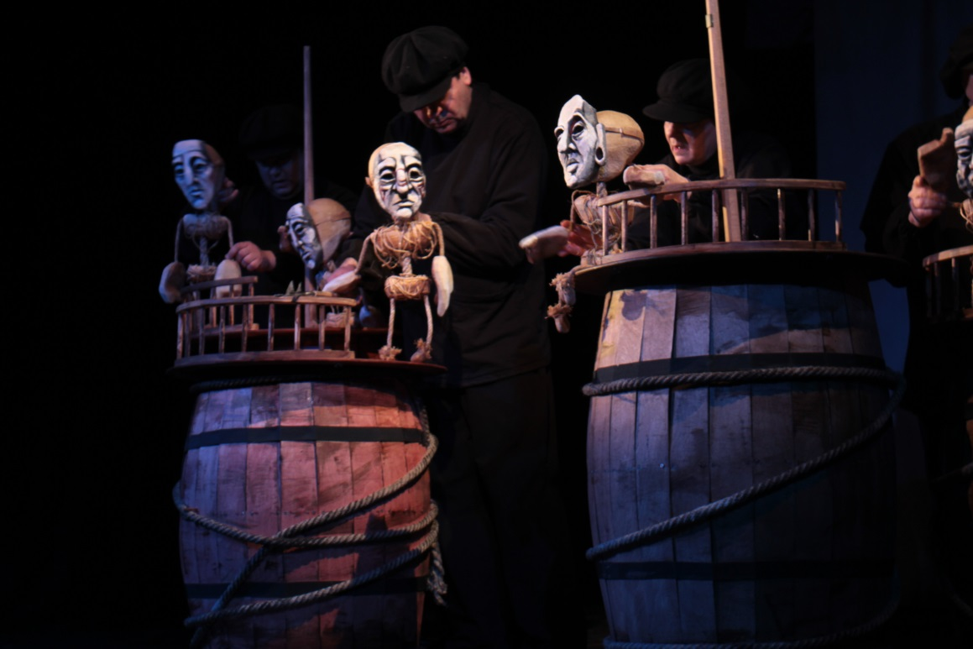

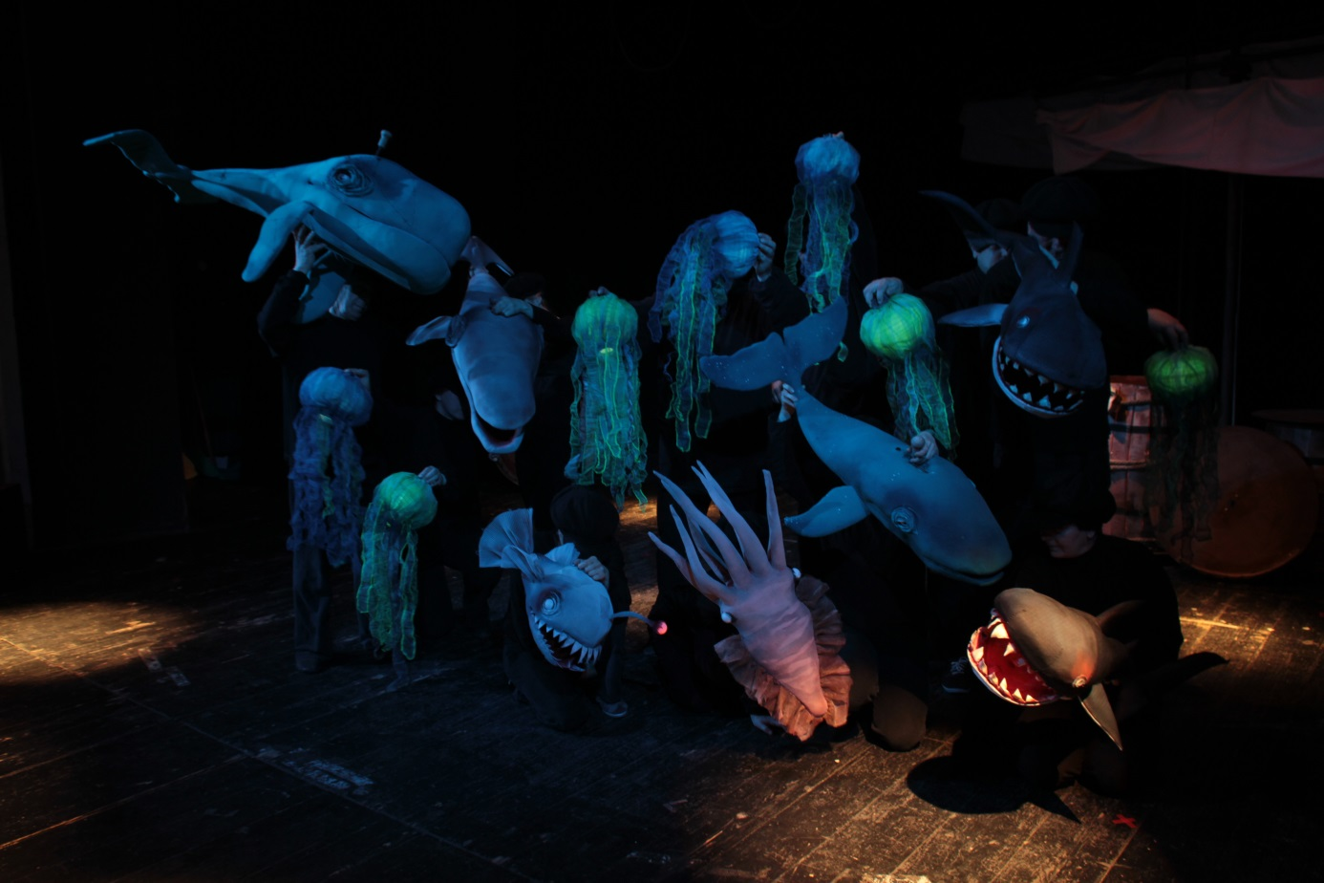

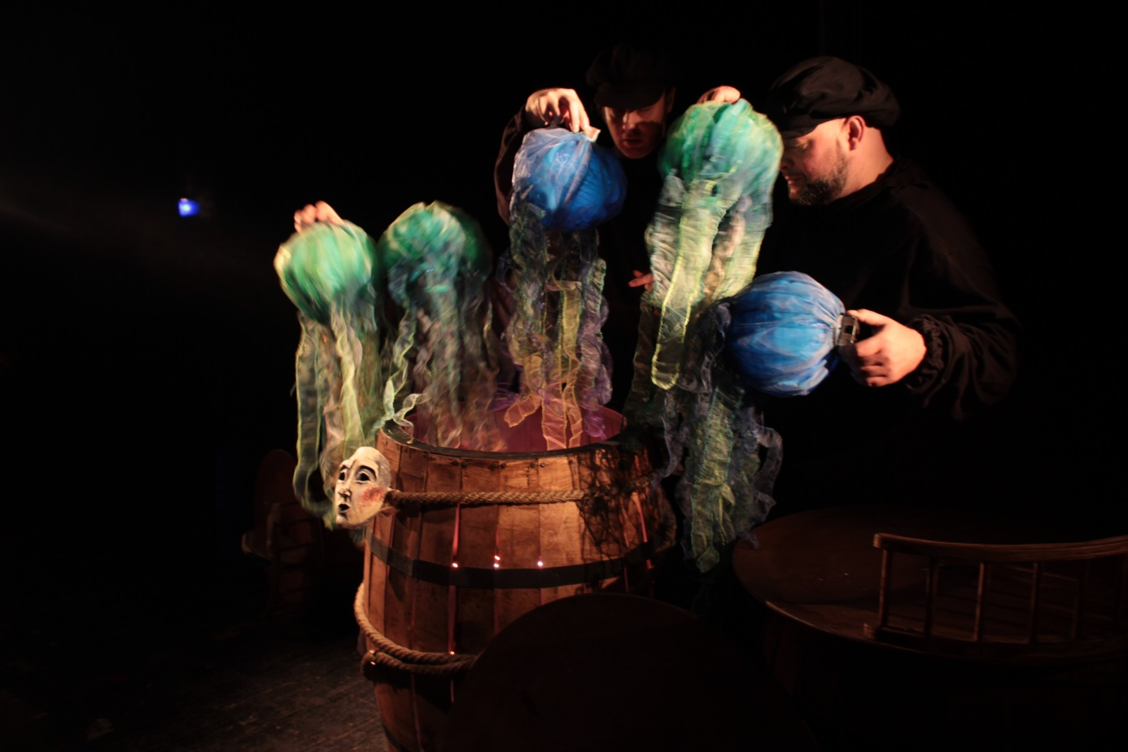

23-Year Dream (2014)

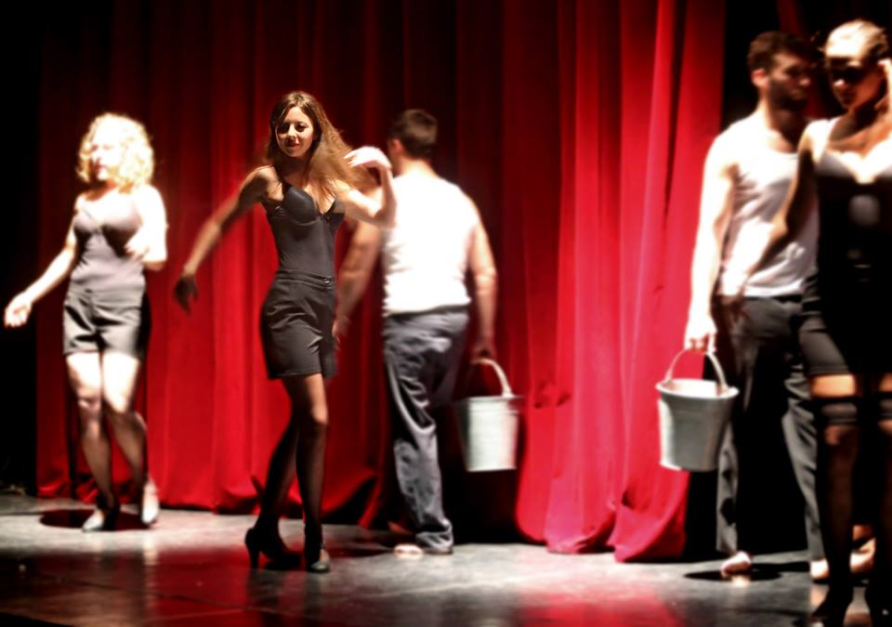

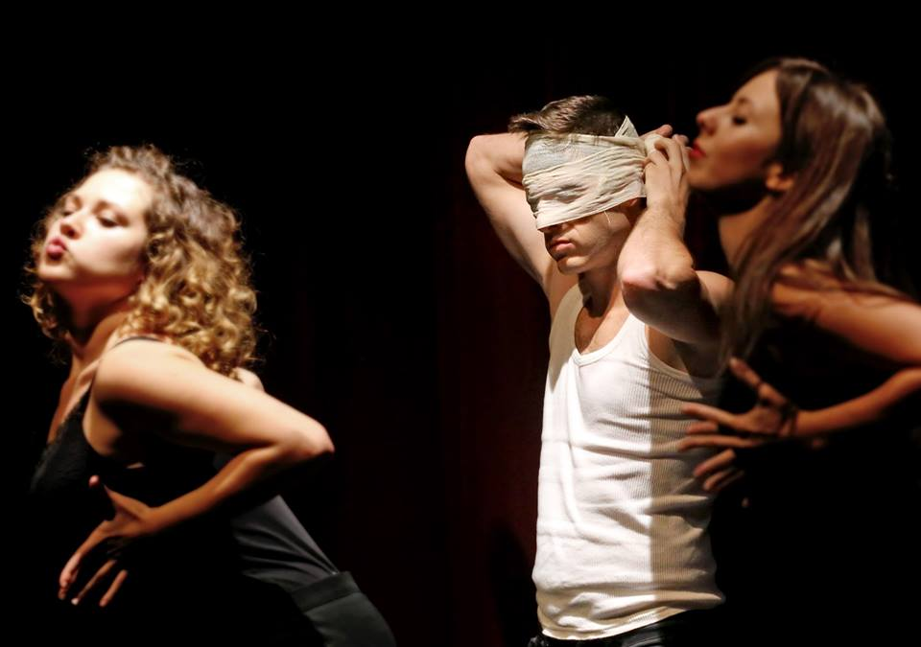

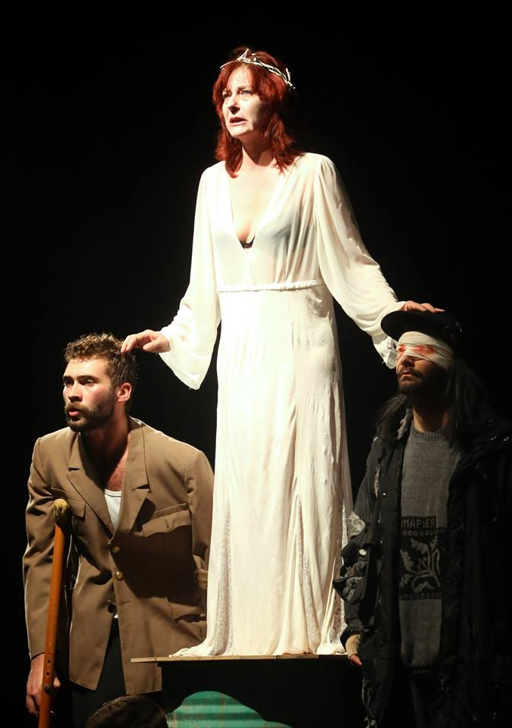

Babett Lies (2014)

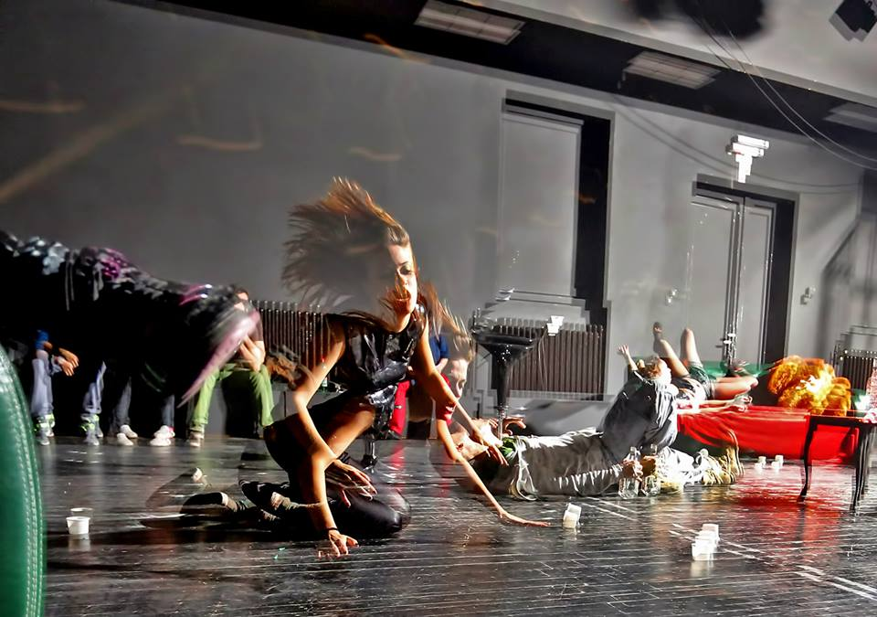 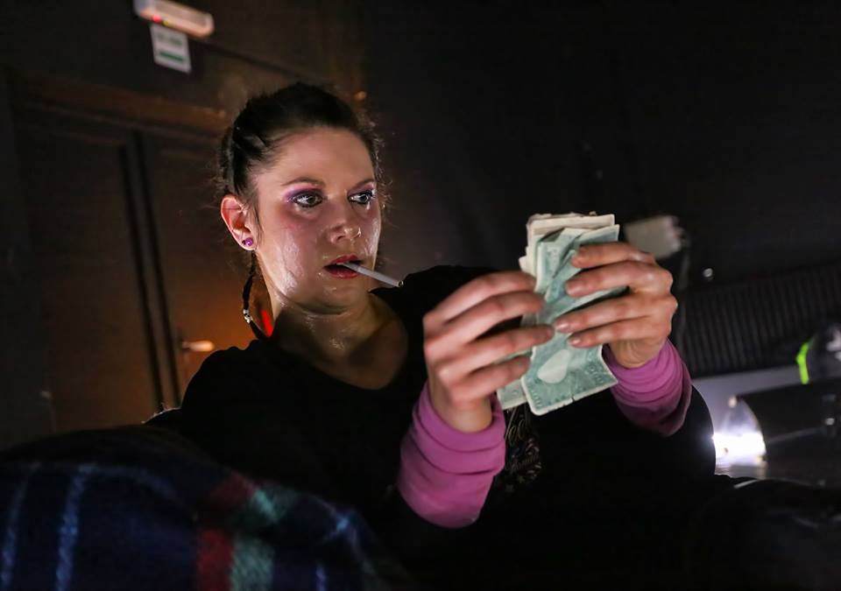 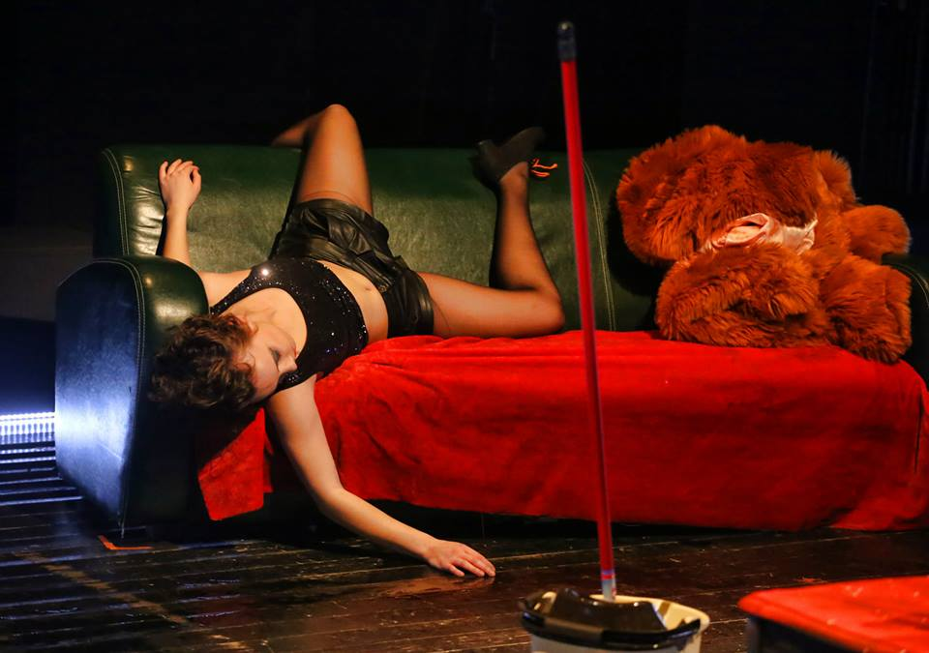

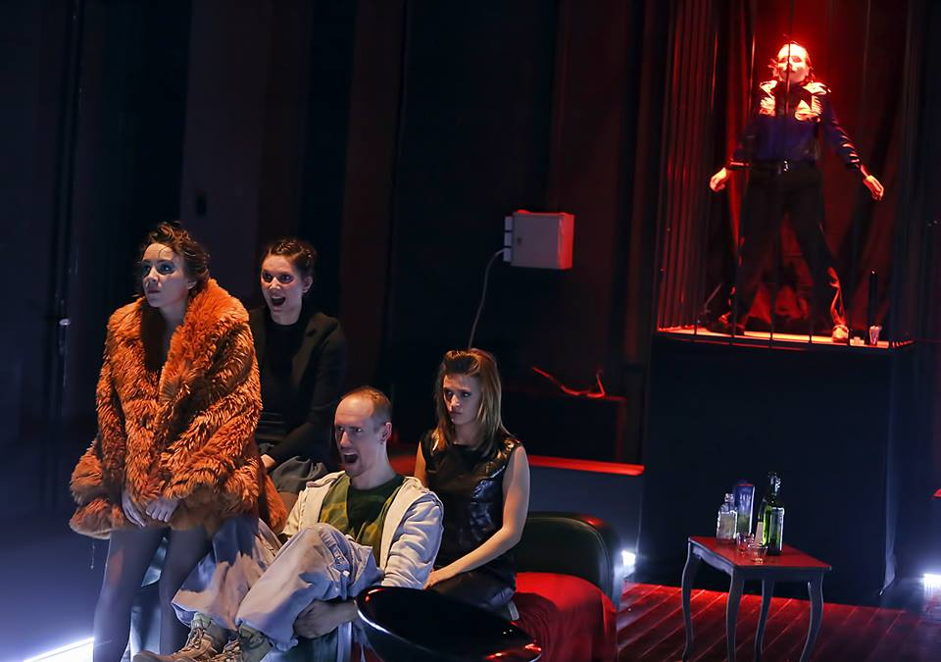

Together (2014)

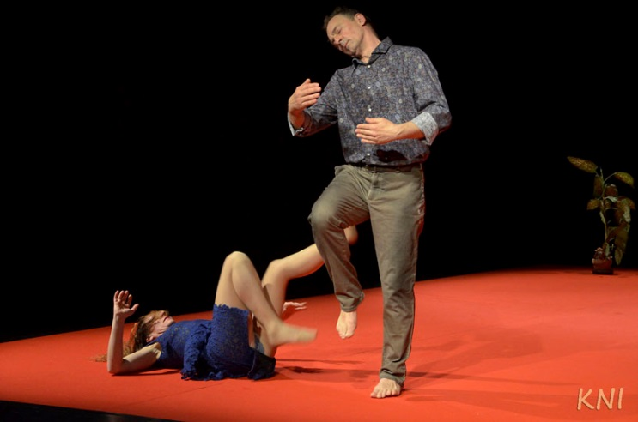

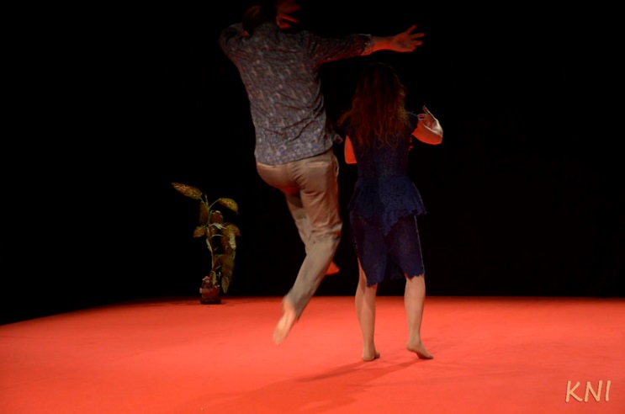

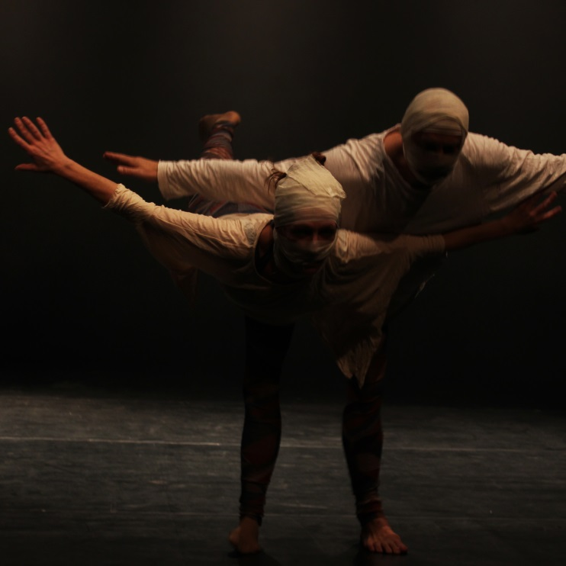

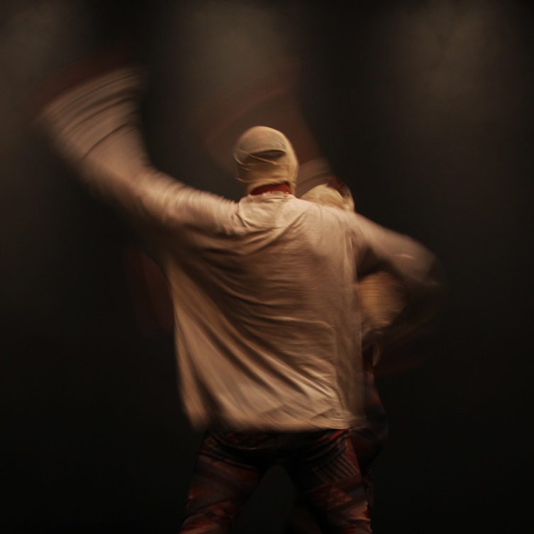

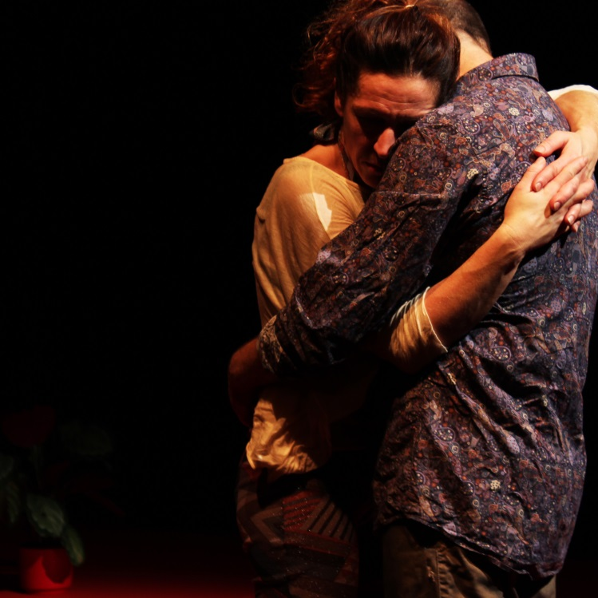

Seven-Headed Fairy (2014)

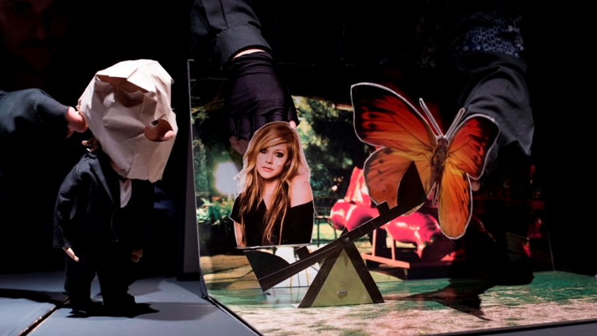

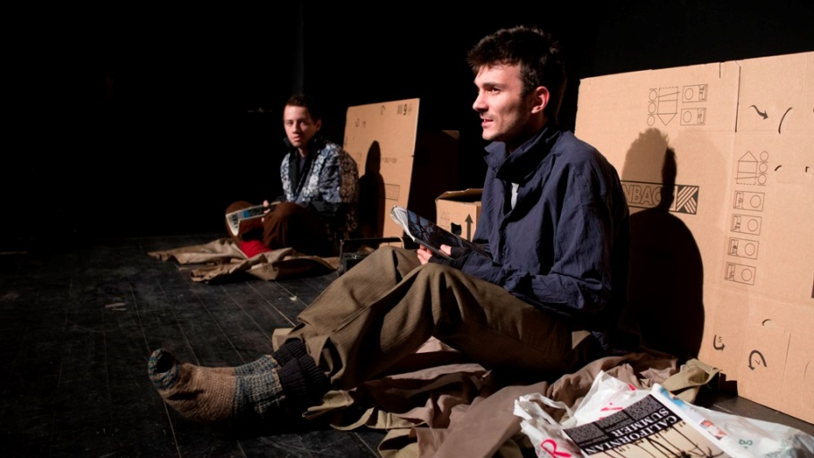

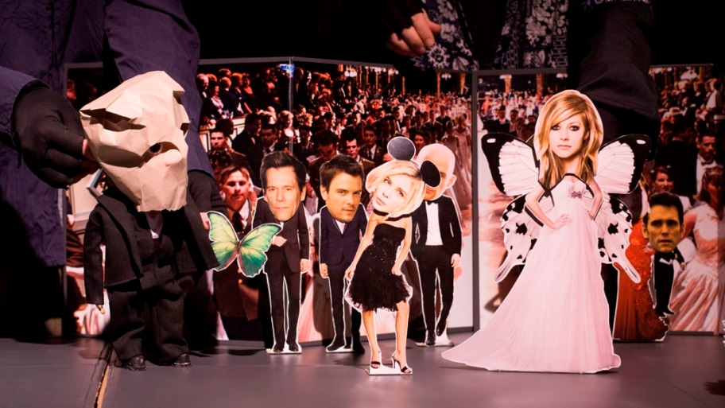

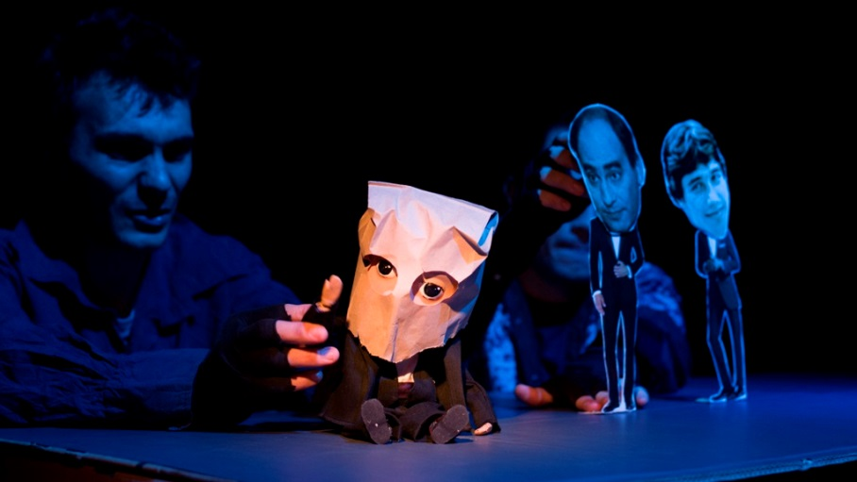

Monologue (2013)

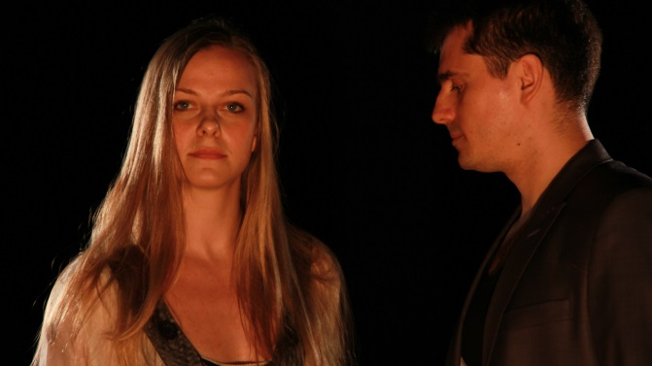

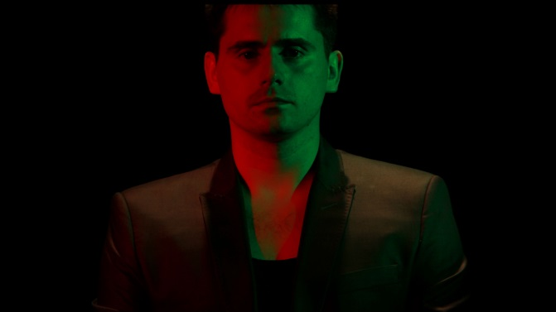

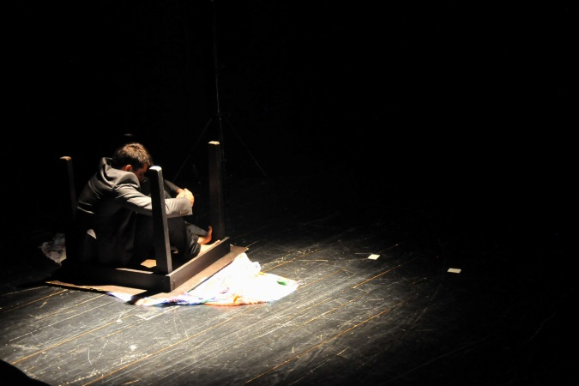

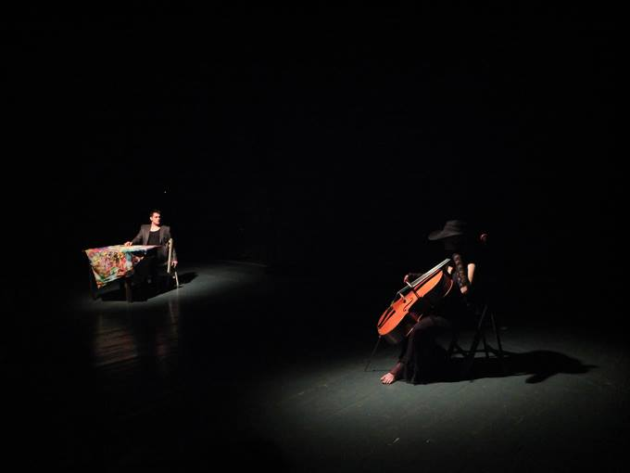

In the Garden of the Selfish Giant (2011)

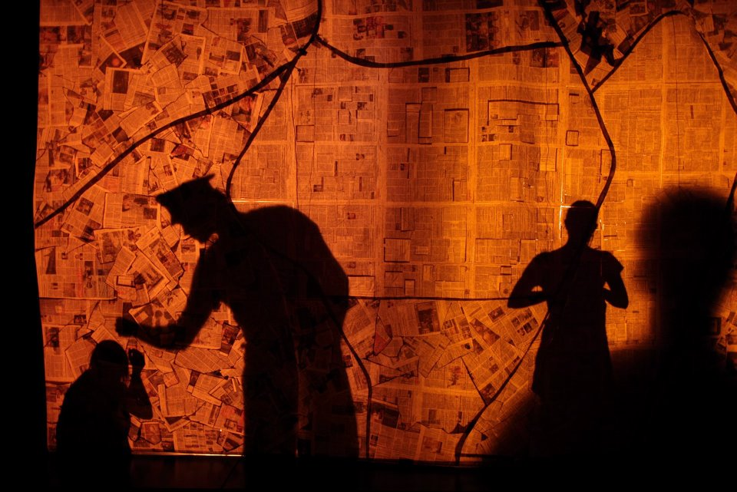

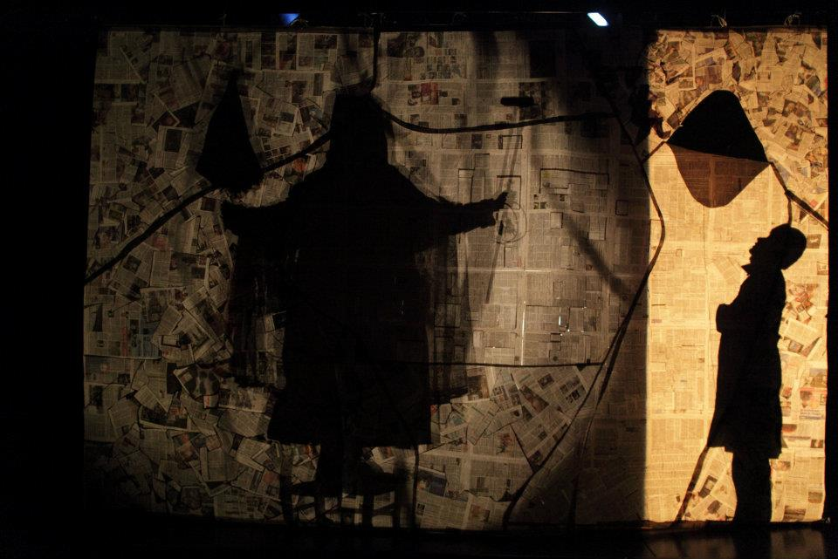

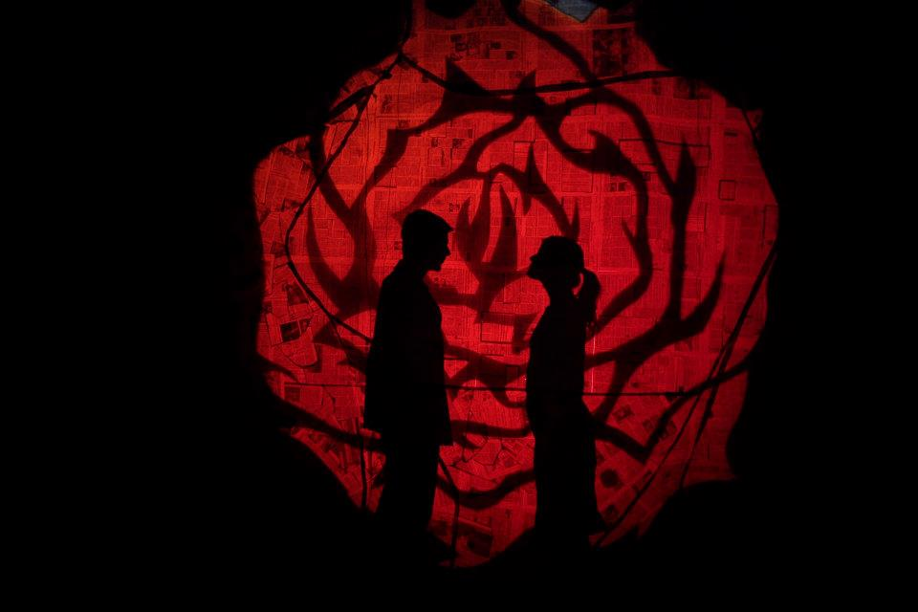

Striped Cat and Miss Swallow (2010)

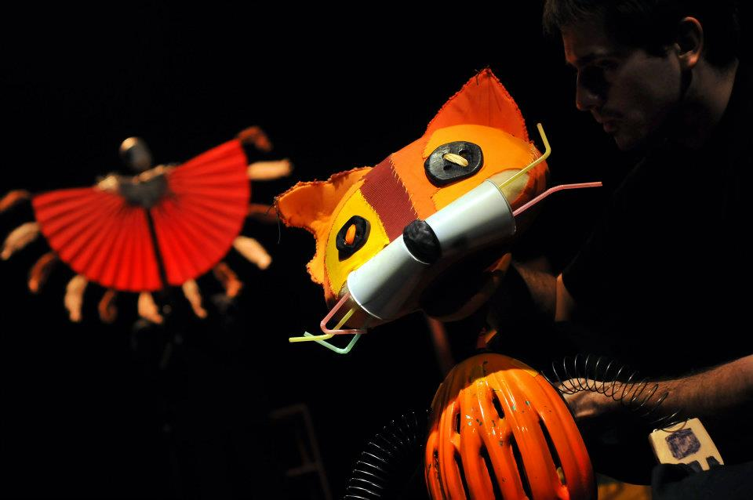

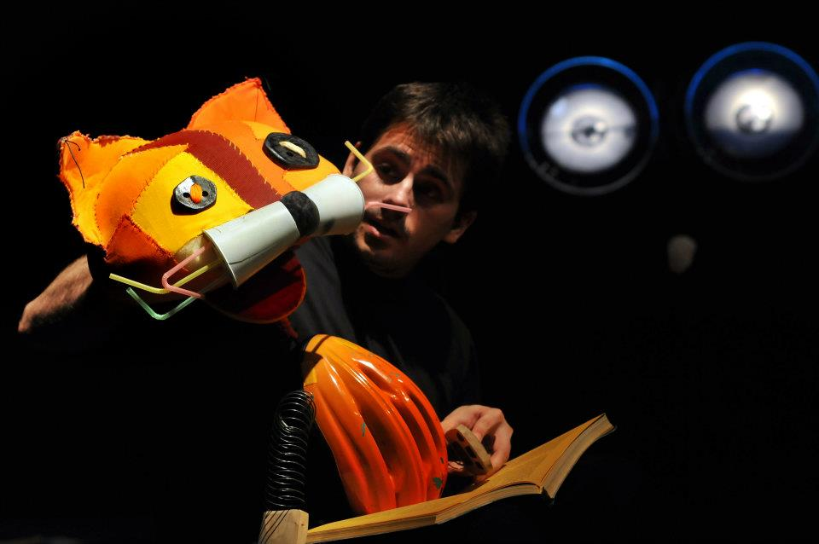

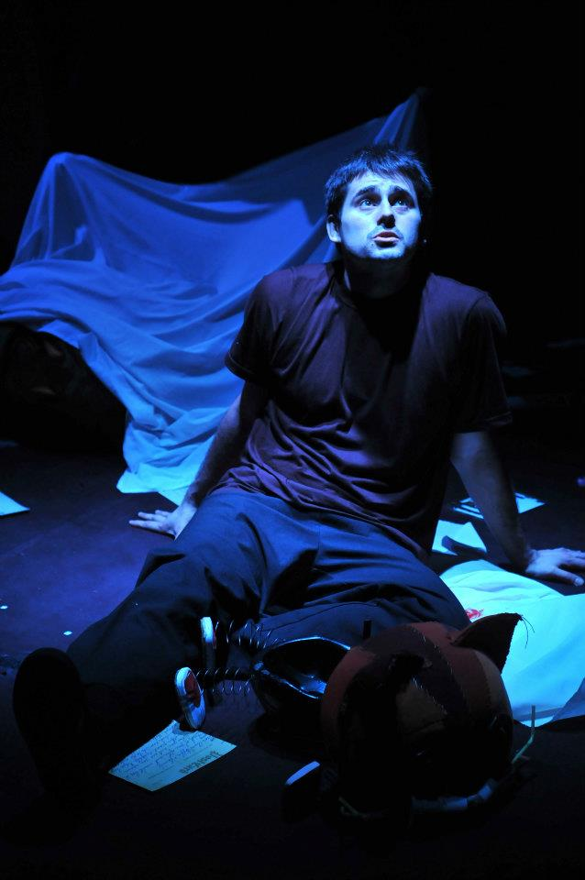

The Sun is Laughing (2009)

