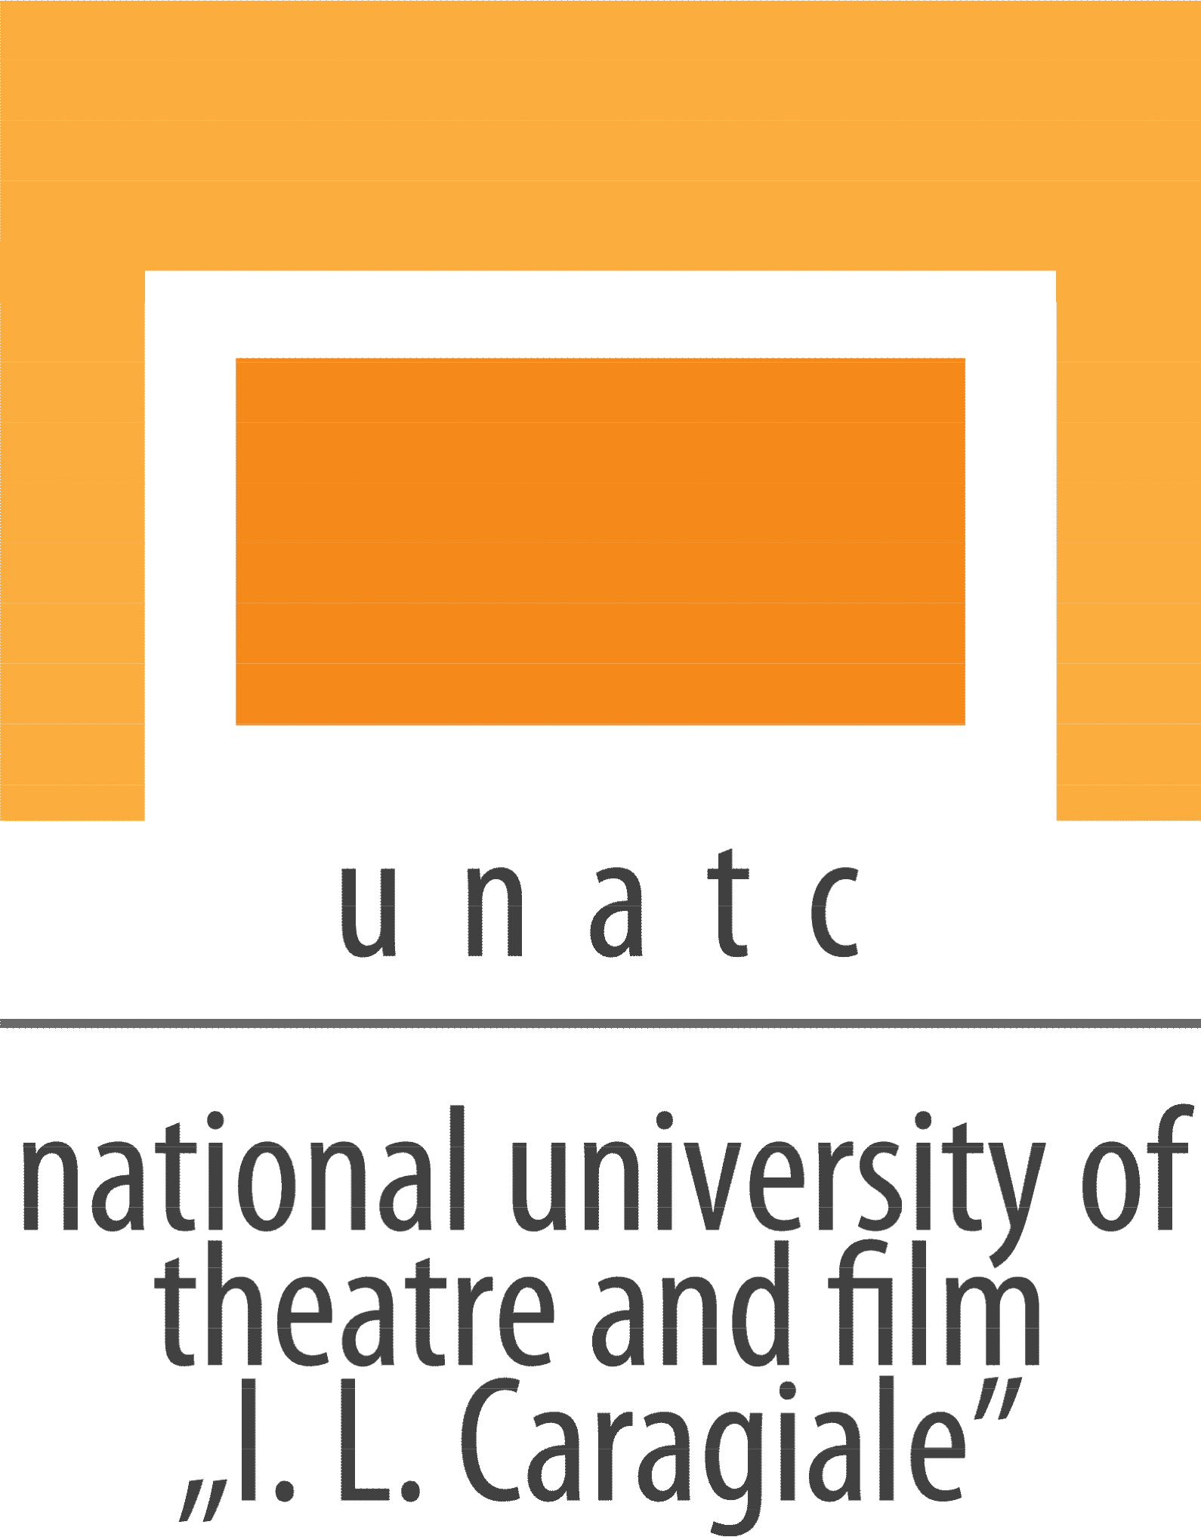 |  | UNATC - The National University of Theatre  and Film “I.L.Caragiale” Bucharest  75-77 Matei Voievod street, 021452  Bucharest, Romania  phone / fax: +4021 252 54 55  e-mail: film.festivals@unatc.ro  www.unatc.ro
Original title: | Mon Ami
English title: | Mon Ami
Production company: | UNATC
Director: | Carina-Gabriela Dașoveanu
Screenwriter: | Carina-Gabriela Dașoveanu
Director of photography: | Ștefan Aghițoaie
Producer: | Daniel Nuță, Ela Gavrilă
Editor: | Ilinca Miroşanu | Trailer:
Sound: | Tijana Marjanović | Facebook:
Prod. design: | Denisa Avram | Imdb:
Music: | - | Movie site:
Cast: Marius Manole, Gabor Bondi, Toma Cuzin, Medeea Marinescu, Doru Cătănescu, Ilinca Hărnuț, Dan Ursu, Cristina Cepraga, Ștefan Niciev, Aurora Cepraga

Synopsis română: Filmul ,,Mon Ami” urmărește povestea lui Marius, un regizor de succes care organizează un casting pentru următorul lui film. Deși Marius pare să aibă totul: o soție caldă, un grup de prieteni buni și o carieră înfloritoare, acesta realizează că se simte din ce în ce mai nefericit. Casting-ul nu merge așa cum și-ar dori el, soția nu îi înțelege nevoile în întregime, iar prietenii lui privesc totul superficial. Marius simte că nu își mai găsește locul până când îl întâlnește la casting pe Stelian, un băiat rom de 14 ani, care îl face pe acesta să se regăsească.

Synopsis English: “Mon Ami” follows the story of a successful film director, Marius, during the casting process for his new project. Although Marius looks to have it all: a loving wife, a group of good friends and a blooming career, he comes to realise that he feels more and more miserable. The casting is not as it should be, his wife doesn’t really understand his needs and the group of friends has a very superficial approach over work. Marius feels lost until he meets Stelian, a 14 years old rroma boy, who makes him rediscover himself.

Short Synopsis: Although Marius is a successful film director, he feels lost in his own universe. The meeting with Stelian, 14 years old roma boy, gives him a totally fresh and young perspective over life.

Logline English: A film director is trying to find his peace of mind during the casting process of his next film.

Festival Presentation (previous screenings):

TIFF
Sarajevo International Film Festival
Angers International Film Festival
Awards:

Technical information

Country: Romanina |  | Production year: |  | 2022
Running time: | 29:50 | Subtitles: |  | English
Color/B&W: | Color
Genre: Drama |  | Sound: |  | Stereo
Filmspeed: | 24 fps
Format: 2:35:1 anamorphic

Available screening formats:

Director’s Bio / Filmography:

Right from her childhood, Carina-Gabriela Dașoveanu was captivated by the world of theatre, being awarded and performing on stages in Constanța, Timișoara, Cluj, San Remo. She was admitted in National University of Theatre and Film “I. L. Caragiale” (UNATC), Bucharest, in Faculty of Theatre and Film, Babeș-Bolyai University, Cluj and in five other top film universities in UK. She continued her studies in UNATC, where she was admitted first of the list. Her graduation film was awarded with the 3’rd prize in Cannes Film Festival at Cinéfondation Section and nowadays Carina is studying for her master degree in Film Directing also at UNATC.

