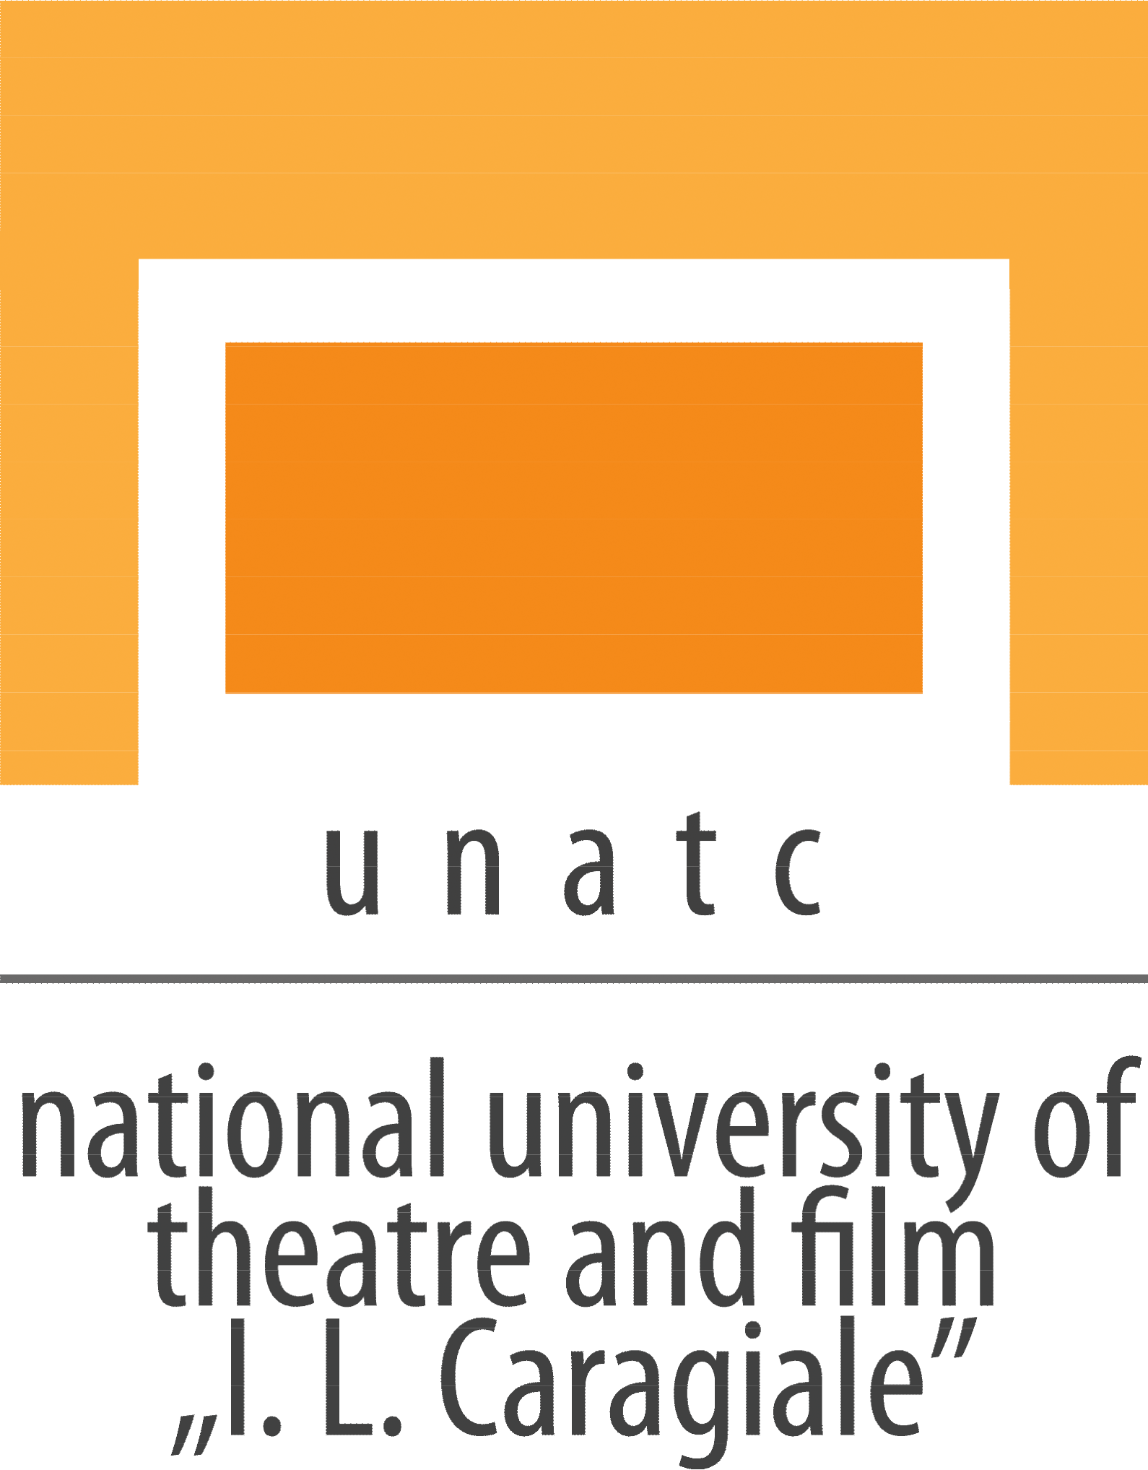 |  | UNATC - The National University of Theatre  and Film “I.L.Caragiale” Bucharest  75-77 Matei Voievod street, 021452  Bucharest, Romania  phone / fax: +4021 252 54 55  e-mail: film.festivals@unatc.ro , alma.buhagiar@gmail.com  www.unatc.ro
Original title: | EDUCAȚIE SENTIMENTALĂ
English title: | SENTIMENTAL  EDUCATION
Production | UNATC - The National University of Theatre  and Film “I.L.Caragiale” Bucharest
Director: | ALMA BUHAGIAR
Screenwriter: | ALMA BUHAGIAR & IULIA LUMÂNARE
Director of photography: | DARIUS DRAGOMIR ONICĂ
Producer: | MARTHA MARMELIUC RUXANDRA MIRUNA ALEXA
Editor: | RAMONA CHISTRUGA | Trailer: TBD
Sound: | VLAD GABRIEL | Facebook:  TBD
Prod. design: | ADELINE ANDREEA BĂDESCU | Imdb:  TBD
Music: NO |  | Movie site:  TBD
SCREENER LINK
Cast: IULIA LUMÂNARE, ROLANDO MATSANGOS, IONUȚ CARAS, LAURENȚIU DAMIAN

Synopsis Lb. română: O seară în familie scoate la iveală mai multe dileme nerezolvate.

Synopsis English: A family evening brings back several unresolved dilemmas.

Festival Presentation (previous screenings): TBD

Awards: TBD

Technical information

Country: Romania |  | Production year: 2023
Running time: 28 minutes, 38 secundes |  | Subtitles:  ENG
Color/B&W: Color
Genre: Drama, Comedy |  | Sound: Stereo 2.1
Filmspeed:
24 fps

Format:
2.39:1

Available screening formats: DCP 24fps

Director’s birthdate:
17 november 1998

Director’s phone number: 0728 393 381

Alma Buhagiar (b. 1998, Bucharest) studied film directing at U.N.A.T.C "I. L. Caragiale" Bucharest, and in 2022 she graduated from the same faculty with a master's degree. Her student films Algae (short fiction-experimental film, 2019), The Last Reverend (short documentary film, 2019), Simple things (short experimental film, 2020) and Together (short fiction film, 2020) have been screened in several film festivals, such as Transilvania International Film Festival (TIFF), Anonimul Independent Film Festival, Șerban Ionescu Film Festival, Filmul de Piatră, French Riviera Film Festival, Bucharest Fashion Film Festival, Pula Film Festival and won "Best Film" Award at the CinemaIubit Film Festival in 2020 (for Together), and "Cinematographic Hopes" Award (for The Last Reverend) at the Romanian Filmmakers Union Ceremony (Gala UCIN), in the same year. In 2021 Alma won the "Gopo Young Hope" Award for the short film Together. She has participated in film workshops such as Let's go Digital (Transilvania International Film Festival) and Film Plus, where she has had the opportunity to work on developing the script for her next film. She has exhibited video-installations at events such as The Night of Galleries in Bucharest, and SUPER. Alma also works since 2020 as a commercial director, and has collaborated with clients such as BRD, Brico Depot, eMAG and Băneasa Shopping City.

- “Algae” (short fiction-experimental, 2019)
- “The last Priest” (short documentary, 2019)
- “Simple things” (short fiction-experimental, 2020)
- “Together” (short fiction, 2020)
- “Sentimental education” (short fiction, in post production)
- “The forest is raging and trying to pass something on to me” (short fiction, in post production)

